#### Ideation Phase

##### Brainstorm and Idea Proritization

|  |  |
| --- | --- |
| **Date** | **19 November 2022** |
| **Team ID** | **PNT2022TMID05601** |
| **Project Name** | **IOT Based Smart Crop Protection System for Agriculture** |
| **Maximum Marks** | **4 Marks** |

**Step : 1**

**Define your problem statement**

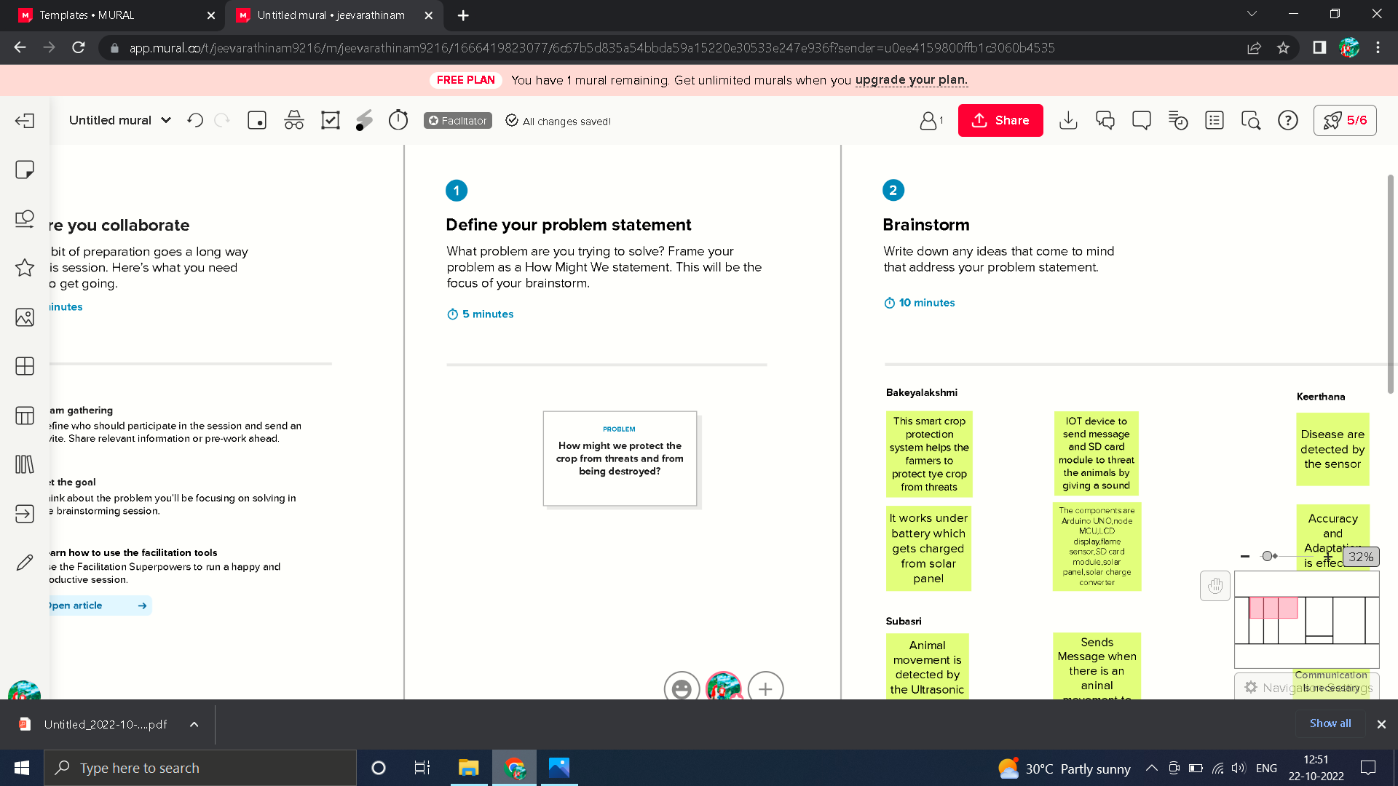

**Step : 2Brainstorm,Idea Listing and Grouping**

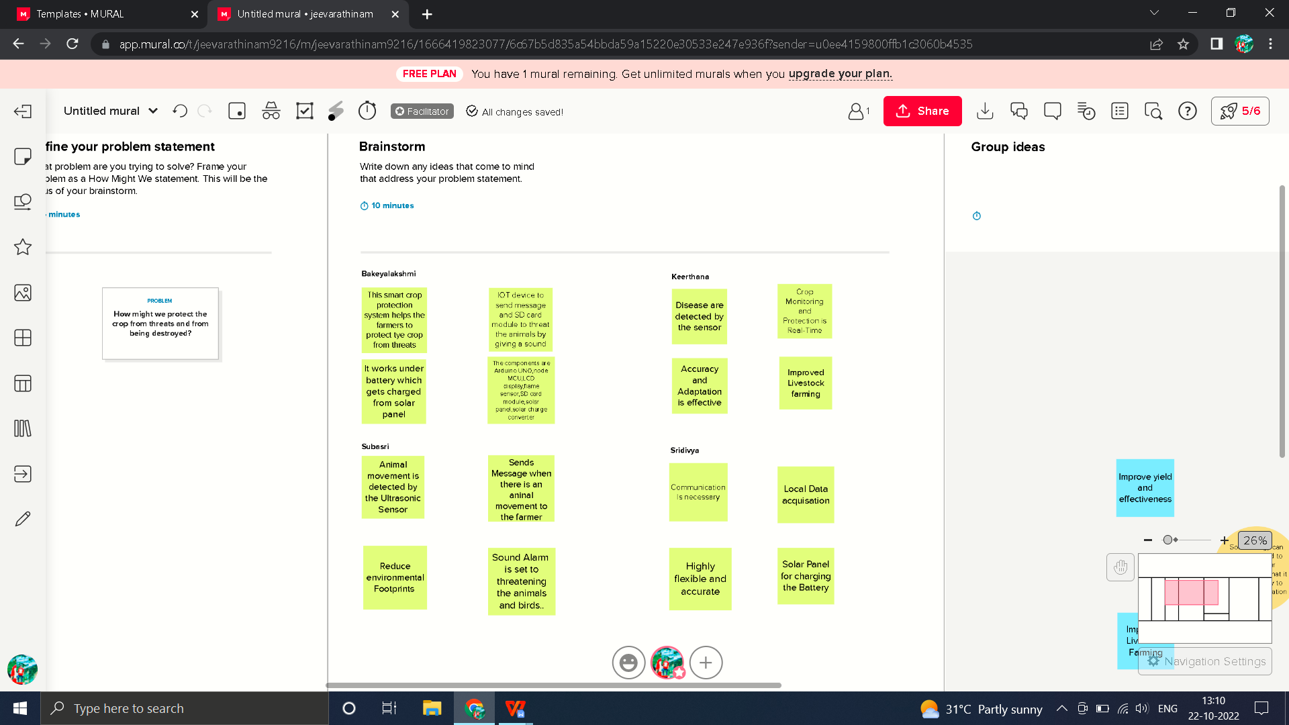

**Step : 3**

**Group Ideas**

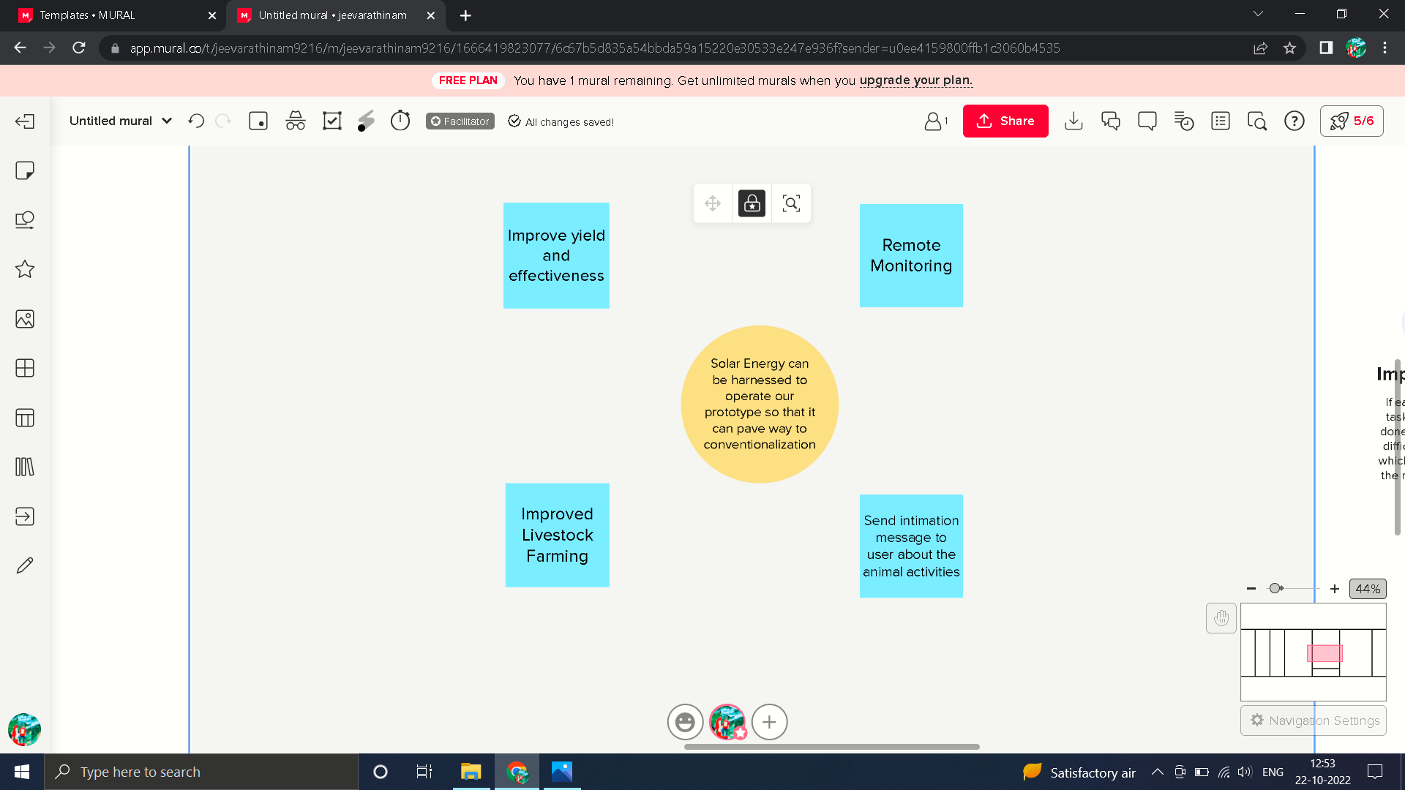

**Step : 4**

**Idea Prioritization**

